Introduction to Computer Systems ELEC1601  
School of Electrical & Information Engineering  
University of Sydney

Remotely Controlled Nuclear Contamination Surveyor

Luke English (470412116)

Date submitted: October 30, 2017

**Introduction**

Since the development of the science of atomic radiation from 1895 to 1945, the harnessing of nuclear energy has been at the forefront of scientific advancement (Hore-Lacy, 2007). However, such power does not come without risks. The dangers of harnessed atomic energy, through nuclear energy plants are far-reaching. Examples like the Chernobyl disaster of 1986 and the Fukushima Daiichi nuclear disaster of 2011 act as grim reminders of the dangers of such power. When such events occur, the levels of radiation inside the disaster zone are far beyond what is capable for the human body to tolerate without risk of radiation sickness and later development of cancer. As a result, clean-up crews cannot proceed inside the zone to survey the area and apply necessary repairs to prevent further contamination. We sought to create a remotely-controlled robot which would be able to proceed into these contaminated areas to detect levels of radiation and other environmental conditions, and ultimately apply necessary repairs.

**Description of Product**

The product is a remotely controllable robot which is used to detect and survey areas believed to contain possible nuclear contamination.

The robot has wheels attached to facilitate movement. It is attached with a Geiger counter to measure ionising radiation, a temperature sensor and an ambient light sensor. These sensors are used to detect and measure nuclear contamination and its effects on the surrounding environment, and infer whether the area is safe for human presence. Once the environmental conditions have been measured by the robot, the data is sent back to the master control device. An infrared light and detector is equipped to facilitate safe automated movement of the robot. In addition, the robot is equipped with a buzzer to play alarms to warn individuals inside the possibly contaminated zone. Real-time controls, as well as an automated sweeping program will come pre-installed on the master control device.

The product could be utilised in the following situations:

1. After nuclear disasters, such as the Fukushima Daiichi nuclear disaster of 2011, the radiation levels are often too high for humans to enter for investigation purposes, even with hazmat suits (hazardous materials suits). As a result, robots are sent in to measure the radiation levels of the various sectors of the contaminated zone. This product can be used in such a situation.
2. Given the possibility of solar powered batteries, the robot could be adapted to be used to assist in scientific explorations. For example, the robot could be used in the surveying of areas before human contact is possible - similar to the Curiosity rover on Mars, measuring environmental conditions and transmitting back to base.
3. With the ongoing threat of nuclear weaponry being used on the world, governments including the USA have recognised the need for nuclear detection devices to defend against the “smuggl[ing of] nuclear weapon[s] or radiological "dirty" bomb[s]” (Gustafson, 2007). This product could assist in such detection.

**Final Representation of Product Idea**

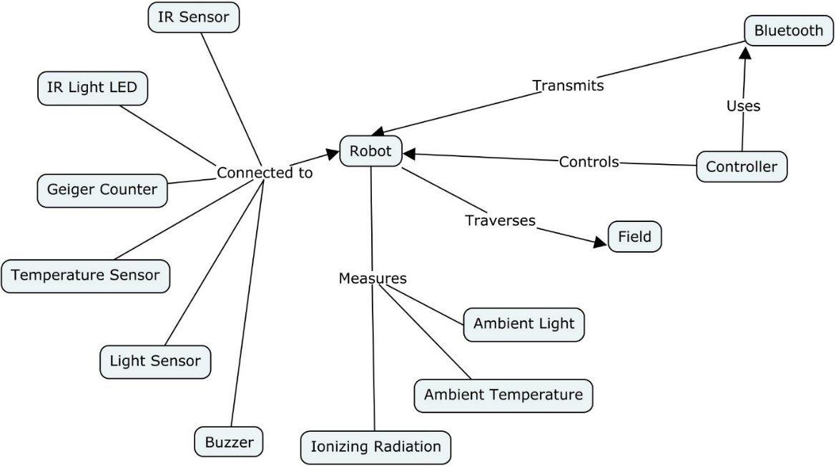

**Implementation**

|  |  |  |  |
| --- | --- | --- | --- |
| **Task** | **Due Date/Week** | **Estimated Time Taken (hrs)** | **Assignee** |
| Brainstorm sensors to use for robot design | 29/10/2017 - 8 | 1 | Luke English |
| Purchase Arduino-compatible Geiger Counter | 01/10/2017 - 8 | 0.5 | Luke English |
| Research conditions of chemically/nuclear contaminated areas | 01/10/2017 - 8 | 2 | Luke English |
| Purchase batteries for BOE-bot | 01/10/2017 - 8 | 0.5 | Luke English |
| Brainstorm code method signatures | 01/10/2017 - 8 | 2 | Luke English |
| Research how to connect Geiger counter to Arduino | 05/10/2017 - 9 | 1 | Luke English |
| Code scaffold constructed for Master and Slave device | 08/10/2017 - 9 | 1.5 | Luke English |
| Purchase tape to attach Geiger counter to BOE-bot | 15/10/2017 – 10 | 0.5 | Luke English |
| Code to be continued | 15/10/2017 – 10 | 4 | Luke English |
| Finish code | 22/10/2017 – 11 | 2 | Luke English |
| Debug code | 22/10/2017 – 11 | 2 | Luke English |
| Rewrite comments; fix intrinsic documentation | 22/10/2017 – 11 | 1 | Luke English |
| Test master and slave device | 29/10/2017 | 3 | Luke English |
| Finalise intrinsic documentation | 29/10/2017 | 1 | Luke English |

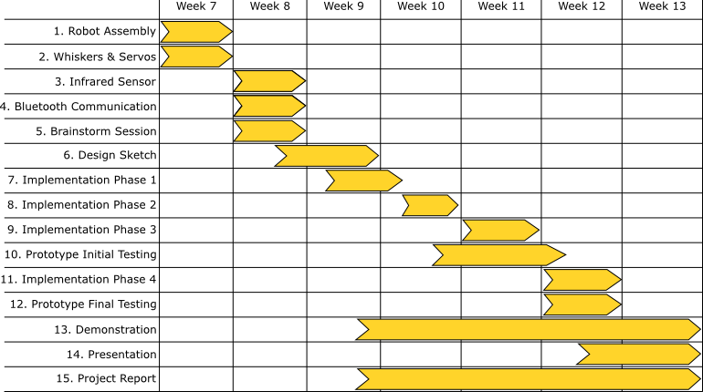

**Flow Chart**

**Flow Chart**

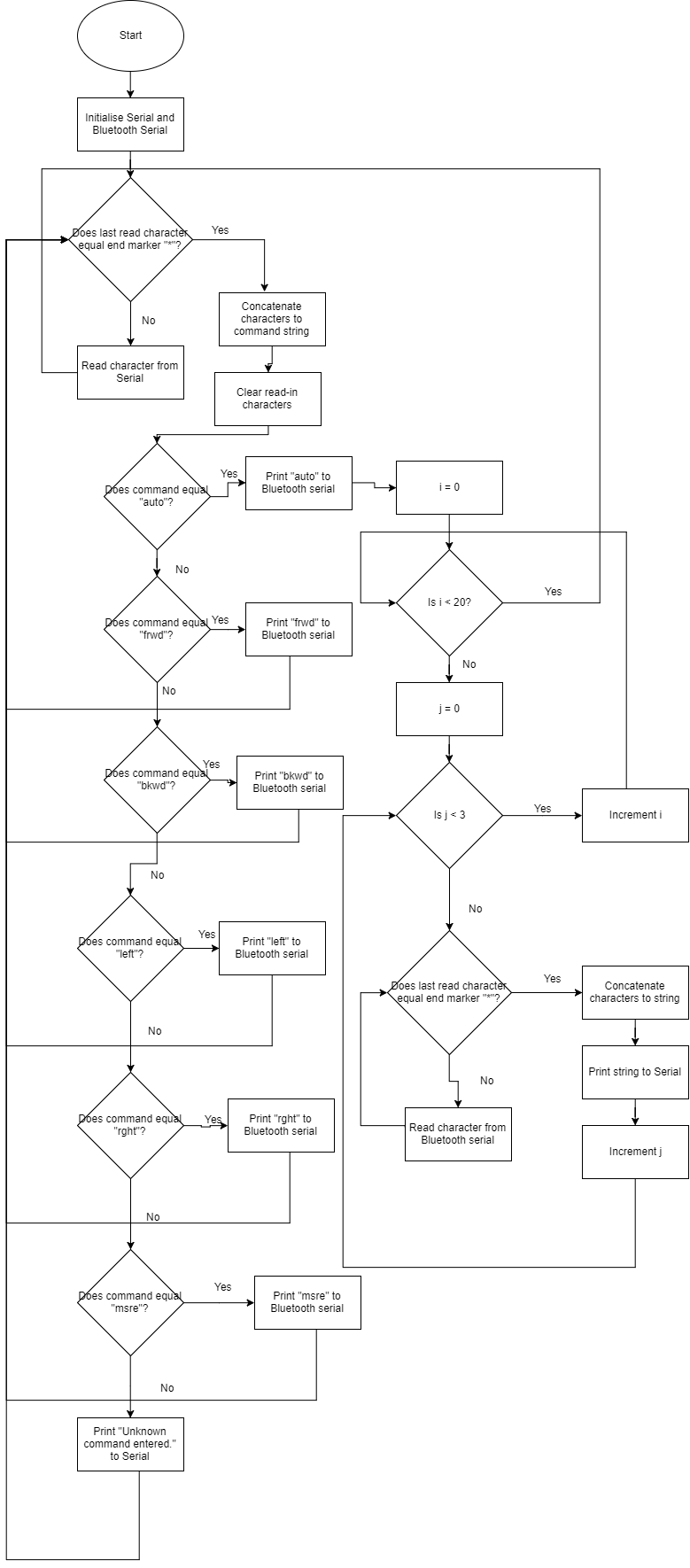**Master: Slave:**

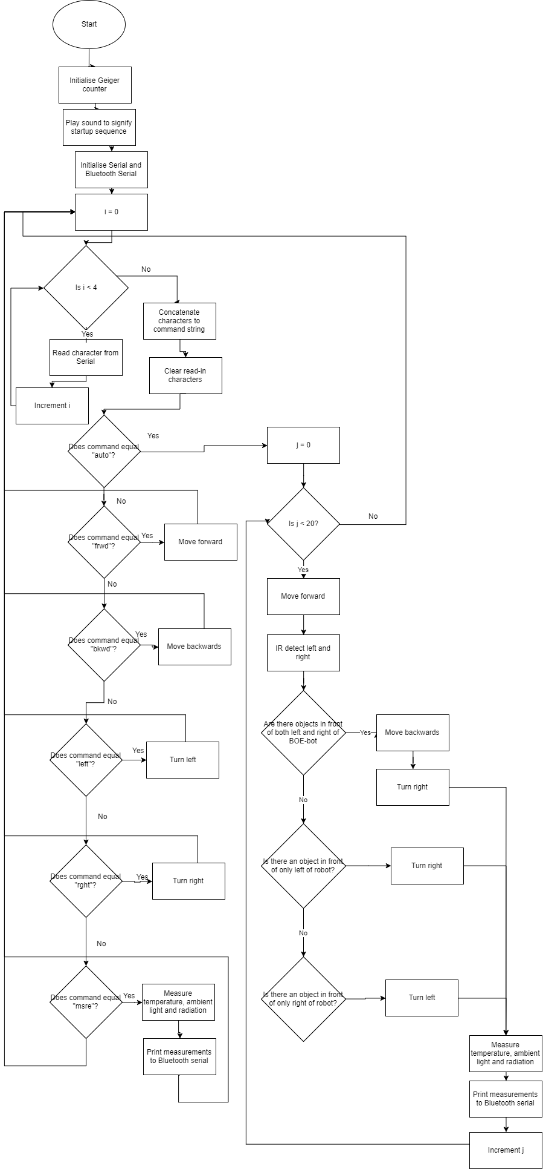

**Pseudo-code**

**Master:**

Setup

Initialise serial and Bluetooth serial

Call setupBlueToothConnection

Loop

Call recvWithEndMarker

Call showNewData

recvWithEndMarkerBlueTooth

while blueToothSerial is available and newData is false

read blueToothSerial into rc

if rc doesn’t equal “*”

add rc to receivedChars array

else

terminate the string with ‘\0’

set newData to true

recvWithEndMarker

*Same as above but replaced blueToothSerial with Serial*

showNewData

if newData is true

if receivedChars equals “auto”

Print to Bluetooth serial “auto”

Set newData to false

Loop 20 times

Loop 3 times

Call recvWithEndMarkerBlueTooth //to receive //measurements

Print receivedChars to Serial

Set newData to false

Else if receivedChars is “frwd”, “bkwd”, “left”, “rght”

Print receivedChars to Bluetooth serial

Else if receivedChars array converted to string is equal to “msre”

Loop 3 times

Print to Bluetooth serial “msre”

Call recvWithEndMarkerBlueTooth //to receive //measurements

Print receivedChars to Serial

Set newData to false

Else //unknown command

Print “Unknown command entered.” to Serial

Set newData to False

//Subroutine to set up Bluetooth connection and connect to slave device

setupBlueToothConnection

Configure Master device to connect to Slave device

**Slave:**

Setup

Play tone to signify startup procedure

Initialise Geiger counter

Initialise serial and Bluetooth serial

Call setupBlueToothConnection

setupBluetoothConnection

Configure Slave device to connect to Master device

tube_impulse

Increment counts

detectRadiation

wait number of ms dictated by logging period

return counts * multiplier

detectTemperature

return (analog reading of pin A0 * 0.004882814) - 0.5) * 100

detectLight

return analog reading of pin A1

measure

Print temperature to Bluetooth serial after calling detectTemperature

Print light level to Bluetooth serial after calling detectLight

Print radiation level to Bluetooth serial after calling detectRadiation

autoSweep

Loop 20 times

Call moveForward

Call irDetect on left and right IR

If both left and right objects are present

Call moveBackwards

Call turnRight

Else if only left object detected

Call turnRight

Else if only right object detected

Call turnLeft

Call measure

irDetect

Turn on IR light

Return digital reading of IR sensor pin

moveForward

Turn on both servos forwards at full speed for 2000 ms

moveBackwards

Turn on both servos backwards at full speed for 2000 ms

turnRight

Turn on servoRight at full speed backwards for 400 ms

Turn on servoLeft at full speed forwards for 400 ms

turnLeft

Turn on servoRight at full speed forwards for 400 ms

Turn on servoLeft at full speed backwards for 400 ms

Loop

While true

If Bluetooth serial is available

Read Bluetooth serial into recvChar

Increment count

If count equals 4

Break

Set count to 0

Call subroutine corresponding to read in command (i.e. “auto” -> autoSweep, “frwd” -> “moveForward”, etc.)

**Prototype Description**

The product was prototyped utilising the Arduino architecture. A master Arduino controller and a slave Arduino Boe-bot communicates via Bluetooth to allow bilateral data transmission. The Boe-bot was equipped with all the aforementioned sensors and their data transmits back to the master Arduino. The controller allows remote control of the Boe-bot. It is connected to a personal computer to act as screen output for the controller.

Feasibility was tested rigorously through diagnostics in varying conditions. This included environments of varying temperatures and light levels. These conditions were manipulated in the laboratory sessions. However, the product could not be tested in a nuclear-contaminated area. Safe-to-handle ionising nuclear radiation emitting materials were not available at the time of testing.

**Conclusion**

The prototype was ultimately successful in all tests. However, testing in areas of nuclear contamination was not possible, due to a lack of radioactive materials. Nonetheless, while the Geiger–Müller tubes could not be stimulated with ionising radiation, the Geiger counter’s detection could be performed by completing the circuit manually (i.e. touching a wire between both electrodes). The Geiger counter measured this output pulse and the measuring subroutine returned the simulated radiation level to the master controller.

The only issue experienced so far with the prototype is the occasional connectivity issues with the Master and Slave devices. However, we suspect this is the nature of the provided Bluetooth modules, rather than a fault of our code. Regardless, more rigorous testing should be performed on the connection between the Master and Slave devices.

While the prototype proved successful, in practicality, such a robot would need shielding from radiation to be useful in areas of high radiation levels. As experienced in the aftermath of the Fukushima meltdown, robots sent into contaminated zones are at risk of damage from excessive radiation levels (Dvorsky, 2017). More research should be performed into methods of shielding mobile robots from ionising radiation. In addition, the prototype did not have a robotic arm, and such would only prove useful as an environmental condition surveyor. For the full product, a robotic arm and other apparatuses which would function to assist with the decontamination process would be included.

**Bibliography**

* Dvorsky, G. (2017). *Excessive Radiation Inside Fukushima Fries Clean-up Robot*. [online] Gizmodo Australia. Available at: https://www.gizmodo.com.au/2017/02/excessive-radiation-inside-fukushima-fries-clean-up-robot/ [Accessed 29 Oct. 2017].
* Gustafson, T. (2017). *Radiological and Nuclear Detection Devices | NTI*. [online] Nti.org. Available at: http://www.nti.org/analysis/articles/radiological-nuclear-detection-devices/ [Accessed 29 Oct. 2017].
* Hore-Lacy, I. (2007). *6. OTHER NUCLEAR ENERGY APPLICATIONS:*. [online] ResearchGate. Available at: https://www.researchgate.net/publication/302450106_6_OTHER_NUCLEAR_ENERGY_APPLICATIONS [Accessed 29 Oct. 2017].